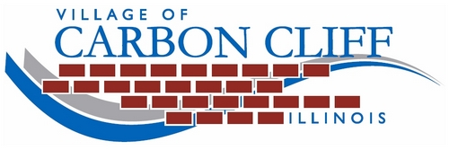
Bulky Item Collection:
Special pickups are available for large bulky items that cannot go into garbage containers for regular garbage collection. One $15.00 sticker equates to the approximate amount of what will fit into a standard F150 pick-up truck bed (8’x8’x2’). Each pick up will be one truck load or less. Entire house clean outs will require a dumpster.
Republic Services provides bulky item collections on Wednesdays only. Items may be placed out on the weekend prior to the scheduled collection date. All items must be out by 6am on the scheduled date.
Please contact the Maintenance Services office at 309-752-1573 ext 0 to schedule the pick-up prior to placing your items out. Items shall be placed in a neatly stacked pile where your normal garbage is picked up.
Guidelines for Bulky Item Pick Ups:
- Small items such as clothes, dishes, and toys must be kept together in a bag, box, or container not weighing more than 50lbs each.
- Carpet may be set out, but must be cut into 4-foot wide sections, rolled up and secured into bundles.
- Wood pieces with nails or staples must have them hammered down or removed.
- Lawn mowers must have all fluids drained.
Bulky item pickups may not be used for televisions, computer equipment, appliances, used tires, household hazardous materials, asphalt, construction material (drywall) roofing materials(shingles), railroad ties, bricks, or concrete.
Unacceptable Item Alternatives:
- Ammunition: Live bullets, explosive materials, fireworks, or other munitions will not be collected.
- Appliances / White Goods (stoves, refrigerators, washers, dryers, dishwashers, air conditioners, dehumidifiers, hot water heaters, etc.) Dispose of household appliances (white goods) free by calling 1.877.934.5378 to schedule a time for curbside pick up.
- Batteries (Rechargeable): May be taken to Batteries Plus during store hours at 300 Avenue of the Cities, East Moline. Rechargeable batteries that are accepted include vehicle, motorcycle, marine, sealed lead acid, NICD (Nickel Cadmium), Ni-MH Nickel Metal Hydride, and LION (Lithium).
- Computers/Televisions: Contact Scott Area Landfill at 563.823.0119.
- Paint: Unwanted or unused oil-based and latex paint products may be taken to the Scott Area Landfill. Contact 563.381.1300 for drop-off date and directions. No charge.
- Tires: Dispose of used passenger tires free by calling 1.877.934.5378 to schedule a time for curbside pickup. Limit of 10 tires per household, per year.

